June 2020



**Software Engineering**

**Graduation Project-II Report**

Covid-19 Detection by Using Chest X-ray

**Consultant: Assist. Prof. Dr. ELNAZ PASHAEI**

**Prepared by**

**Emre GÖL**

**Kaan Berke UĞURLAR**

I Project Description 4

1 Project Overview 5

2 Related Work 5

3 The Purpose of the Project 5

3.1 The User Business or Background of the Project Effort 6

3.2 Goals of the Project 6

3.3 Measurement 6

4 The Scope of the Work 10

4.1 The Current Situation 10

4.2 The Context of the Work 11

4.3 Work Partitioning 11

4.4 Competing Products 12

5 User Scenarios 13

5.1 User Scenario List 13

5.2 Individual User Scenarios 13

6 Stakeholders 15

6.1 The Client 15

6.2 The Customer 15

6.3 Priorities Assigned to Users 16

6.4 User Participation 17

6.5 Maintenance Users and Service Technicians 17

7 Mandated Constraints 17

7.1 Solution Constraints 18

7.2 Implementation Environment of the Current System 19

7.3 Off-the-Shelf Software 19

7.4 Anticipated Workplace Environment 20

7.5 Schedule Constraints 21

7.6 Budget Constraints 21

8 Proposed Method 22

8.1 Convolutional Neural Networks 22

8.2 Transfer Learning 25

9 Naming Conventions and Definitions 26

9.1 Definitions of Key Terms 26

10 Used Tools 27

10.1 Programming Languages 27

10.2 Frameworks 29

10.3 Other Useful Languages 30

10.4 Platforms 31

11 Relevant Facts and Assumptions 34

11.1 Facts 34

11.2 Assumptions 34

II Requirements 35

12 Software Requirements Specification 35

13 Behavioral Diagrams 36

13.1 Use Case Diagrams 36

13.1.1 Registration Use Case 36

13.1.2 Login Use Case 37

13.1.3 Upload an Image Use Case 37

13.1.4 Enter the Operation Id Use Case 38

13.2 Activity Diagram 39

13.3 Sequence Diagram 41

13.4 Communication Diagram 42

13.5 Interaction Overview Diagram 42

14 Functional Requirements 44

14.1 Details of a Customer 44

14.2 Details of a Customer’s Operation 44

14.3 Diagnose 44

14.4 Accepting Payment to Accelerate the Process 44

15 Data Requirements 45

16 Performance Requirements 46

16.1 Speed and Latency Requirements 46

16.2 Precision or Accuracy Requirements 47

16.3 Capacity Requirements 47

17 Dependability Requirements 47

17.1 Reliability Requirements 47

17.2 Availability Requirements 48

18 Security Requirements 48

18.1 Access Requirements 48

18.2 Data Integrity Requirements 49

18.3 Privacy Requirements 49

19 Quality Requirements 50

19.1 Efficiency Requirements 50

19.2 Portability Requirements 50

III Design 51

20 System Design 51

20.1 Design Goals 51

21 System Architecture 52

21.1 Overview 52

21.2 Dynamic Models 53

21.2.1 Class Diagram 53

21.2.2 Component Diagram 54

21.2.3 Deployment Diagram 54

21.2.4 Object Diagram 55

22 Outputs 56

22.1 Web Application 56

22.1.1 Back-end Endpoints 56

22.1.2 Front-end Main Page 57

22.1.3 Front-end Sign-In Page 57

22.1.4 Front-end Sign-Up Page 58

22.1.5 Front-end Forgot Password Page 58

22.2 Mobile Application 59

22.2.1 Mobile Application Main Page 59

22.2.2 Mobile Application Register Functionality 59

22.2.3 Mobile Application Select Image 60

22.2.4 Mobile Application Image Upload 61

22.2.5 Mobile Application Get Result 61

I Project Description

# Project Overview

A brief description of the product to be produced, before getting into details. The COVID-19 pandemic, also known as the coronavirus pandemic, is an ongoing pandemic that is fatal. As of 9 November 2020, more than 50.4 million cases have been confirmed with more than 1.25 million deaths attributed to COVID-19, and more than 32.8 million recovered. As it is known, early diagnosis is vital in any of the diseases. In such cases as COVID-19, early diagnosis can save millions of lives. If a patient is diagnosed, then he can be quarantined and prevented from spreading by the authority. This is the place where our project steps in. The project can diagnose COVID-19 by only using x-ray images of a potential patient which helps to protect millions.

# Related Work

Doctors often use x-ray scans for diagnosing broken bones. However, they have used them too for detecting types of cancer, pneumonia and other developing conditions. The x-ray’s length will depend on which part of the body the doctor is examining. However, it generally only takes a few minutes.[1] X-ray images are in 2D, while CT scan images are 3D. The CT scanning machine rotates on an axis and takes various 2D images of an individual’s body from multiple angles.

As it was mentioned before, x-ray images take up less space than CT (Computer Tomography) images. The proposed method of the paper of Classification of COVID-19 patients from chest CT [2] does these classification operations on CT images. So, the model is exposed some alternations in order to use it efficiently for chest x-ray images and the most import thing is that the classification operation will be deployed on both web and android. Anyone who can upload their chest x-ray image properly will be informed about the result of the diagnosis.

# The Purpose of the Project

## The User Business or Background of the Project Effort

The project has been planned over 3 (three) months and contributed by professionals in this area (i.e., doctors and professors). Subsequently, it was decided on the neural network architecture — which was the best among various of them. In those days, there were some nonsensical apps, that want you to blow through your microphone to detect whether you are infected or not, on the market. People who have created those apps were mocking with users and it was obvious that something must be done to prevent people from believing that absurdity. There was a clear need for a system that gives a genuine result whether you are infected or not. In the beginning, users will be able to upload X-ray images of their chests and get the results as soon as possible. There is going to be a variety of improvements in the oncoming versions not only about speed but also on the accuracy and image’s part.

## Goals of the Project

The goal of this project is to use Artificial Intelligence, especially a deep learning-based approach, to detect COVID-19 infection from chest X-ray images. In addition, it is to verify and test the convolutional neural network for classification. The diagnosis of COVID-19 is typically associated with both symptoms of pneumonia (Pneumonia is an infection that inflames the air sacs in one or both lungs) and Chest X-ray tests. Chest X-ray is the first imaging technique that plays an important role in the diagnosis of COVID-19 disease. Another goal is to accurately identify at least 93% of COVID-19.

## Measurement

To test the goal of the project, it is necessary to calculate the accuracy of COVID-19 test. So, what is accuracy? The accuracy of a machine learning classification algorithm is one way to calculate how much the algorithm classifies a data point correctly. Accuracy is the number of correctly predicted data points out of all the data points. How accuracy is calculated:

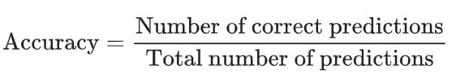

Figure 3.1: Accuracy Calculation Method

Accuracy can be defined as the percentage of correctly classified cases where the number of true positives, false negatives, false positives, and true negatives are expressed by TP, FN, FP, and TN, respectively. TPR and TNR can both be closer to 100 percent for successful classifiers.

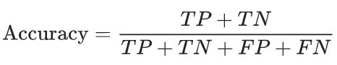

Figure 3.2: Accuracy Calculation by Confusion Matrix

In terms of accuracy, the actual value is the value obtained through observation or measurement of the available data. It is often called the value observed. The predicted value, based on regression analysis, is the value of the predicted variable.

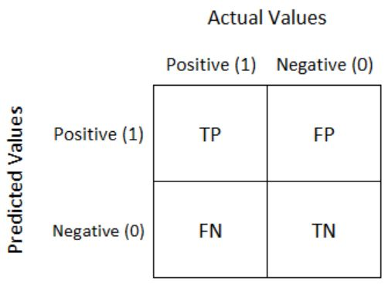

Figure 3.3: Confusion Matrix

In the project we are going to identify at least %99 of the COVID-19 correctly. In there, we calculate at least %99 using the accuracy of the dataset.

There are some other metrics to evaluate measurement. It is already mentioned what true positive, true negative, false negative, false positive is. Afterwards, what recall, and precision is. Precision measures the number of predictions for the positive class that belong to the positive class. Recall measures positive class predictions produced in the dataset by all positive samples.

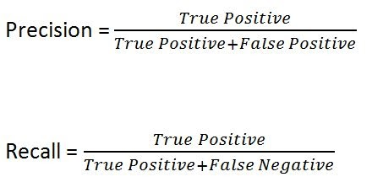

Figure 3.4: Recall and Precision Calculation by Confusion Matrix

Accuracy is concerned with both positive and negative sides. What if is it just tests the positive hand? It might be a safe way to use the F1-score for that. An indicator of the precision of a test is the F1-score. In comparison to accuracy, the F1-score only tests accuracy and recalls the positive group.

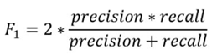

Figure 3.5: F1-Score Calculation Method

There are some metrics generally used for medical areas. These are sensitivity and specificity, and they are quite popular metrics. Sensitivity is the ability of a test to accurately identify patients with a disease. The ability of a test to accurately identify people who do not have the disease.

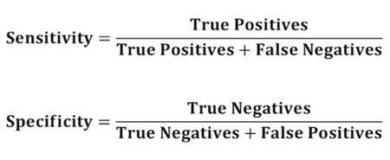

Figure 3.6: Sensitivity and Specificity Calculation by Confusion Matrix

If is necessary to know the relationship between sensitivity and specificity, what will it be used? For this, ROC curve can be used. Then, what is the ROC curve? ROC curve is a graph that shows performance of a classification.

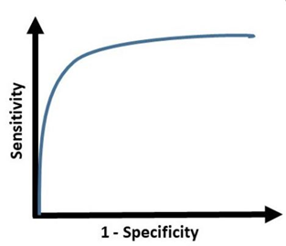

Figure 3.7: Sensitivity Over Specificity Plot

The true positive rate, which is sensitivity, is plotted in a ROC curve based on the false positive rate, which is specificity for a parameter's different cut-off points. A sensitivity and specificity pair corresponding to a particular decision threshold is defined by each point on the ROC curve.

It may also be a good idea to find summary of the ROC curve. There is an AUC for that. AUC means Area Under the Curve which measures the two-dimensional area under the ROC curve.

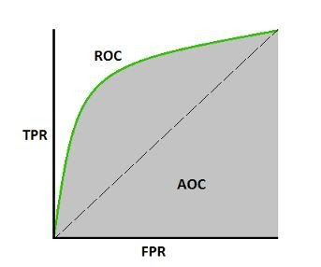

Figure 3.8: ROC and AOC Curves

# The Scope of the Work

Scope of Work is the field in a contract where the work to be done is explained. The Scope of Work should include all milestones, reports, deliverables and final products expected to be achieved by the performing party. The Scope of Work should also include a timetable for all deliverables. The Scope of Business also defines the business environment in which the product will be used.

## The Current Situation

The current situation of COVID-19 is affecting almost all countries around the world. New cases and deaths of people due to COVID-19 are increasing. Some countries and territories deal with the second wave of COVID-19. Even some of them are dealing with the third wave. Many countries try to find the vaccine and some of them succeed.

The current situation is dealing requirements before the implementation part. We have been dealing with the planning, analyzing, and designing parts of the project very carefully and successfully.

## The Context of the Work

Work context refers to concepts that can be used to describe the specific context of different works in the same profession. The working context can describe, for example, a workplace, types of companies, environmental conditions, products, technologies or business activities.

This product will be used by doctors, nurses and health care workers. So, this product will be used in hospitals. Hospital is an institution that is equipped for diagnosing and curing the disease both medical and surgical. Hospitals are the main place for detection and cure of COVID-19. Types of hospitals are an important part of health care. Some of the hospitals don’t even have X-ray devices for detection of disease. For those hospital’s options of detection of COVID-19 are PCR and rapid diagnostic tests. But if hospitals have x-ray devices, we recommend them to use it for diagnosing of COVID-19 because it is fast and effective.

Our product is highly recommended for detection of the disease. It is so simple to understand the system for use. Any person who has the X-ray film upload the film, wait for the process and the result will be printed on the screen. This workplace that runs the film is a computer or an android device. The requirement of the devices is internet connection.

## Work Partitioning

The event list includes the following elements:

●      Uploading chest X-ray as an image

●      Probability of having the disease

●      Users (doctor, nurse or health worker) upload a chest x-ray as an image and wait for the process. After that, the program will print the result.

Using our program is very effective. You can see the result very fast. It is faster than other diagnosing ways like PCR and rapid diagnostic tests. People who take PCR or other tests will get a result in 48 hours. Imagine how much the disease will change if we take the results in one hour. People who take other tests will be still working or interacting with other people so it will increase the disease transmission. If they could get chest X-ray results, they could go directly in quarantine and that would decrease so much the number of cases and deaths.

## Competing Products

To compare the product with other alternatives that already exist, it must be understood well. First, it needs to be comprehended that what do the other products on the market do exactly. Secondly, what can be added extra to the other products to create a brand-new one. However, it was discussed with all the developers that the product must be faster and better. On the other hand, if the product cannot be used by anyone on the face of the planet, then it is nothing but a waste. A light bulb went on in every individual's head in the team simultaneously. These bulbs led the project to a broader area.

The product has now two different kinds of areas to serve. Anyone, who is mature enough to know how to use a smartphone, can use the product both by installing its mobile application and uploading her/his chest x-ray image easily or by clicking its website and again following the same uploading procedure. Either way is elementary level and sufficient for a complex project like this. Any other project, which has the same goal with this project, does not have any place to serve neither their technology nor results, yet this project has bested all over its opponents based on accuracy.

# User Scenarios

Scenarios are somewhat informal stories describing how the end users would use the product once it is completed. They take the form of narratives and may involve specific individuals and examples.

## User Scenario List

The user scenario list is quite simply a list of the user scenarios that will appear in the next section. It is a good idea to either number or name each scenario for later reference, and it can also be a good idea to organize the list so that related scenarios appear together. (Depending on the naming / numbering scheme, they can be grouped into sections and subsections, etc.)

## Individual User Scenarios

User scenarios are written in a natural narrative fashion, easily understood by clients and other non-technical stakeholders. Each one tells a story of how the end user is expected to eventually use the finished product. For instance, in both cases image(s) should not be any blurred or glared or as little as possible to prevent to detect wrongly.

**Register:**

**Customer:** Selena

**Goal:** To have a new account for the application.

**Start condition:** Selena entered all required fields in register page.

**Trigger:** Required field is fulfilled.

**End condition:** Register succeed.

**Login:**

**Customer:** Selena

**Goal:** To login without hesitation with registered information.

**Start condition:** Selena entered all required fields in login page.

**Trigger:** Required field is fulfilled.

**End condition:** Login succeed.

**Upload Image:**

**Customer:** Selena

**Goal:** To upload image.

**Start condition:** Selena clicked required button in main page and choose a x-ray(image) from personal device.

**Trigger:** Button is clicked, and x-ray is chosen.

**End condition:** Image is uploaded.

**Payment:**

**Customer:** Selena

**Goal:** To pay the bill.

**Start condition:** Selena choose the fast deliver.

**Trigger:** Selena chosen the fast deliver.

**End condition:** Payment is handled.

**No payment:**

**Customer:** Selena

**Goal:** To access the service without payment.

**Start condition:** Selena choose the slow deliver.

**Trigger:** Selena chosen the slow deliver.

**End condition:** No payment for service is handled.

**Fast deliver:**

**Customer:** Selena

**Goal:** To operation diagnosis report.

**Start condition:** Selena pay the bill.

**Trigger:** Selena paid the bill.

**End condition:** diagnosis report delivered in 5 min.

**Slow deliver:**

**Customer:** Selena

**Goal:** To access diagnosis report.

**Start condition:** Selena did not pay.

**Trigger:** Selena paid the bill.

**End condition:** Diagnosis report in 2 hours.

**Result:**

**Customer:** Selena

**Goal:** To access result.

**Start condition:** Selena entered required field in main page.

**Trigger:** required field is entered.

**End condition:** Result delivered.

# Stakeholders

## The Client

Clients will be private hospitals or clinics, mostly. According to the accuracy rate we offered, some of the head doctors of the relevant hospitals were thrilled. We are not looking for many clients thanks to the alpha version of the product which will be released by us, anytime soon. Even though clients provide money and space to build a product, we want to release it for benefit of humanity. Also, Clients, who supported us in the first place, will have some special access through the product, undoubtedly.

## The Customer

The customers are anyone who has internet access. They will open either the internet page of the product or the android app and upload their chest x-ray image (s). If uploading would be finished successfully, the system will show a result to the customer in 2 hours.

In spite of the product will be released as free, a system that involves anything we need working properly will also have some particular needs and to meet them, we need to earn as much as money the product needs. We will not show ads to prevent irritating the customers, but we determined to ask for money, which is an insignificant amount, to show results as soon as possible.

## Priorities Assigned to Users

* Key users: They are critical to the continued success of the product. Give greater importance to requirements generated by this category of user. In this case the key users will be the doctors who can help to continue the success of the product by interpreting the results, suggesting new techniques on improving the speed of detection or at least leaving a comment about UI/UX designs in both app and website.
* Secondary users: They will use the product, but their opinion of it has no effect on its long-term success. Where there is a conflict between secondary users’ requirements and those of key users, the key users take precedence. Secondary users would be any adult who could use the product appropriately. They may not add things to the product, but the developers can deduce things by interpreting the behaviors of the secondary users.
* Unimportant users: This category of user is given the lowest priority. It includes infrequent, unauthorized, and unskilled users, as well as people who misuse the product. If the subject is medical, then no user is unimportant but, in this case, there is an exception. The exception is children. They might not know how to use the product and upload some irrelevant images. Which makes children have the lowest priority.

## User Participation

The most critical part of the product’s improvement is user participation. Once the alpha version of the product is released, so many people will be willing to use the product, but it will need some improvements, eventually. Even though ordinary users would not be able to contribute, their logs are going to be inspected and there will be enhancements on the product if needed.

Furthermore, the clients’ participation means a lot more than regular users. Firstly, they will have the products way before the regular user has it. Secondly, they will provide some high-quality feedback due to avoid spending money for nothing. Last but not least, they have a medical background, and this is such a marvelous thing to build a medical product because the clients can be the director for the functionality of the product.

## Maintenance Users and Service Technicians

Maintenance users are a special type of hands-on users who have requirements that are specific to maintaining and changing the product. In the project, maintenance users will be the clients who are doctors, especially, and employees in the hospital. They have every right to criticize and maintain the product.

# Mandated Constraints

This section describes constraints on the eventual design of the product. They are the same as other requirements except those constraints are mandated, usually at the beginning of the project. Constraints have a description, rationale, and fit criterion, and generally are written in the same format as functional and nonfunctional requirements.

## Solution Constraints

This specifies constraints on the way that the problem must be solved. Describe the mandated technology or solution.

Description:

In this paper, a convolutional neural network (CNN) is used to classify the COVID-19-infected patients as infected (+ve) or not (−ve).

Rationale:

COVID-19 patients must be detected as soon as possible. A model which is created by plain CNN is not satisfying. Accuracy must be higher whilst prediction does not take too much time.

Fit criterion:

The initial parameters of CNN are tuned using multi-objective differential evolution (MODE). Extensive experiments are performed by considering the proposed and the competitive machine learning techniques on the chest CT images. Extensive analysis shows that the proposed model can classify the chest CT images at a good accuracy rate.

Description:

The product shall accept X-ray chest images.

Rationale:

Users want to upload input images easily

Fit criterion:

Both the mobile app and websites should be understood by users at first sight. Apart from the sophisticated artificial intelligence model, that is used to predict, UI/IX design will be minimal and even a 7-year-old would use it although the audience is not her/him.

## Implementation Environment of the Current System

This describes the technological and physical environment in which the product is to be installed.

By the time it was decided to build the product, all the technological and physical environments, which the product is to be installed, were determined. For building the product, all the newest and the stabilized of the state-of-art technologies are used. Thanks to the best tools in the market, developing the product, running it on the server and the other users to use it were eased.

To begin with, the deep learning model was created and trained on TensorFlow’s Keras API by using public datasets, and thanks to features of the API, it was feasible to both saving and loading the model that was trained. Moreover, training was half of the project because if you cannot serve what you have done, then it can be said that you have done nothing, basically. Thanks to TensorFlow Lite, the model’s size decreased but the accuracy of the model was not affected. Then, the lite model was transferred to the Android project to use it on the Android app. Whilst the Android app’s outputs have been working quite well and sufficient, then the idea of using the Lite model on the website is become sensible due to the normal model’s heaviness. Finally, the TensorFlow model has been switched to the Lite model in order to reduce heaviness and increase the prediction time in the backend of the website. In the backend, Python programming language was used due to working with TensorFlow would be easier with the native language the model has been trained and as Python’s FASTAPI framework was used as a backend framework because of it is easy to read, write and relatively fast.

## Off-the-Shelf Software

Initially, it needs to be clarified that what is “off-the-shelf” software. If the software needs to be specially configured to match the customer’s needs, then the software is not “off-the-shelf”.

The product, which has been describing in the report, is off-the-shelf because a client won’t have to add any configuration to it. The client or the customer is going to upload her/his chest X-ray image, then the product will assign a number to it to avoid confusion. This is all the users will do.

The product does not get any off-the-shelf application to run, although it is off-the-shelf. The product was created by configuring all the hyperparameters and adding more to the trained models. Needless to say, the website and the app created from scratch.

## Anticipated Workplace Environment

There is not anticipated workplace environment for using the product, but a proper chest x-ray image must be uploaded into the system not to obtain an error or, worse, a misleading result, such as false negative. In that case, the result could be catastrophic. There will be precaution appeared on the screen once the user open product’s user interface.

The chest x-ray is one of the foremost common imaging tests performed in clinical practice, generally for cough, shortness of breath, chest pain, chest wall trauma, and assessment for the occult disease. normal x-rays are performed with the patient standing facing an X-ray film or digital cassette, 6 feet far from an x-ray tube. The tube fires x-rays thru the patient from the lower back to front, i.e., posterior to anterior (PA). This reduces the magnification of the center and different anterior mediastinal structures that are placed near to the film within the PA position. different factors to contemplate for a decent quality chest x-ray are centering (the trachea ought to be equal between the clavicular heads), penetration (the spine should be simply clear through the internal organ density), and breath effort (at the full inspiratory effort, the anterior finish of the correct sixth rib should purpose mid-way on the right hemidiaphragm).

## Schedule Constraints

Schedule constraints are any known deadlines or windows of opportunity. It is crucial to identify critical times and dates that have an effect on product requirements.

The vast majority of the medical sector has been looking for a product like this for over 12 months. The product’s marketing opportunity is enormous, and investors will trust the project blindfolded. Not to exaggerate, the project gives power to its developers to select the investors, but the product must be ready —or at least an alpha version is released— for letting developers have this kind of authority.

The schedule has been varied several times due to technology and procedure issues. Nonetheless, the final schedule was decided eventually. The project must be ready at the end of January, uttermost. The beginning of February is not even a matter of discussion. Besides the client and the many customers are waiting for the product and the financial impact will be huge if the product is late even a day, the whole human race needs a product like this. That is why the product will be ready on the 15th of January and even if the project has been developing by testing, it will take another 15 days to make sure that the product is almost perfect to serve the human race.

## Budget Constraints

The financial budget for the project is so low that a student can create this project in her/his room, but the real budget for the project is time. Every part of the project wants more time than any others in the market.

The time budget is very narrow, and this steers the planners to either hire more developers/mentors or buy/rent much more powerful servers to train models by using brute force instead of training wisely. These days, servers are server rents are lower than mentors', then the team has decided to rent a powerful server to train the model by using the cross-validation method which was surprisingly satisfactory.

To answer the following question “Is it realistic to build a product within this budget?”, it totally is. In the first place, the project was handled by two students who have an average budget. Later on, a few hospitals wanted to invest in the product after the alpha version has been released. If the investments come true, then the product will rival the companies, globally.

# Proposed Method

This section will indicate the proposed convolutional neural networks (CNN) for classification of COVID-19 infected patients from chest X-ray images. In this project, COVID-19 patients from chest X-ray will be classified by using convolutional neural networks [3]. Required parts will be developed around the essential idea.

## Convolutional Neural Networks

Convolutional neural network (CNN) [3], a class of artificial neural networks that have emerged as dominant in various computer vision tasks, is attracting interest throughout a lot of domains, such as radiology. CNN is designed to automatically and adaptively study spatial hierarchies of features via backpropagation through the use of a couple of constructing blocks, which include convolution layers, pooling layers, and fully connected layers. This part of the report of the project gives an angle on the fundamental principles of CNN and its application to diverse tasks and discusses its challenges and future guidelines withinside the subject. Two challenges in making use of CNN to the medical duties, small dataset and overfitting, may also be included in this part of the report, in addition to strategies to reduce them. Being acquainted with the principles and advantages, in addition to limitations, of CNN is vital to leverage its potential in diagnosing diseases, with the purpose of augmenting the overall performance of medical personnel and enhancing affected person care.

1. Feature Extraction:

Feature extraction is a significant approach to decreasing the size of high-dimensional data is the choice of features. It begins from an initial collection of measured data and generates derived values called features, intended to be descriptive and non-redundant, to promote the subsequent steps of learning and generalization and, in certain instances, to contribute to better human interpretations.

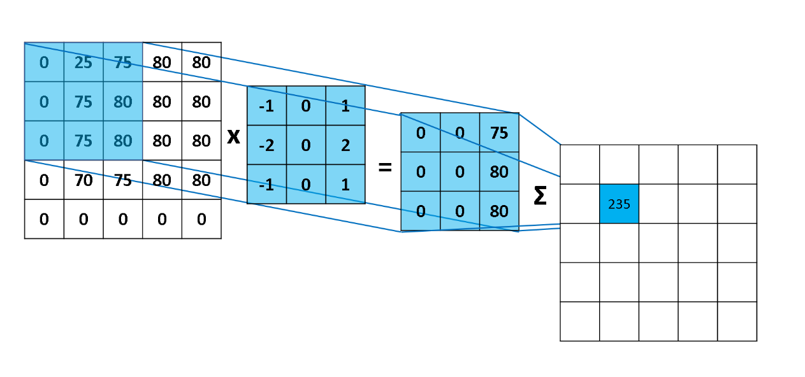

Figure 8.1: Convolution Process Leads to Feature Maps [4]

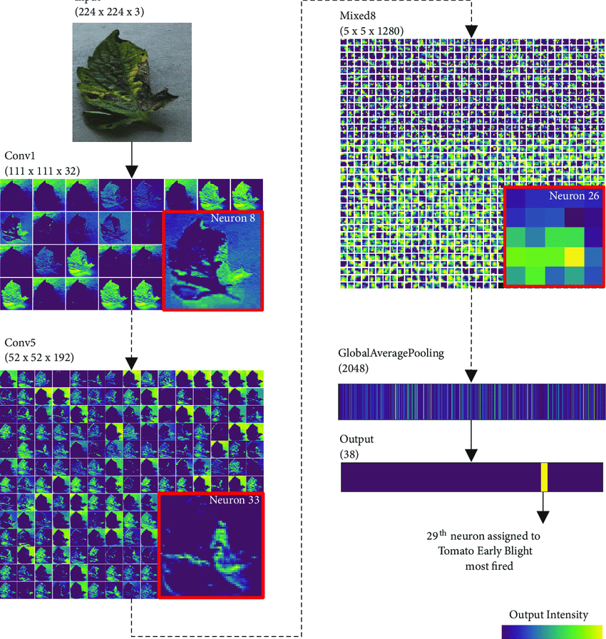

Figure 8.2: Outputs of Intermediate Layers for Detecting Plant Disease [5]

1. Classification

With the idea of deep learning, the models are trained better and are able to identify different levels of image representation. The convolutional neural networks revolutionized this field by learning the basic shapes in the first layers and evolving to learn features of the image in the deeper layers, resulting in more accurate image classification. Fully connected layers serve as a classifier. It uses derived features and evaluates the likelihood of an item in the picture. In order to create non-linearity and mitigate overfitting, the activation function and dropout layer are typically used.

## Transfer Learning

Transfer learning is a machine learning methodology in which knowledge gained during training on one type of problem is applied to other, comparable problems. Instead of building a deep neural network from scratch and training it, which can be a cumbersome task, it can be find an existing neural network architecture an already trained one that accomplishes the same task on the table that it is tried to solve. The layers of the existed neural network that are essential for the task can be reused, while also making changes to the fully connected layer to correspond the problem.

The Visual Geometry Group at Oxford University gave the VGG its name. The model VGGNet has become as popular as the group itself right after being submitted to ILSVRC in 2014 [6]. Because of its deeper design and smaller kernel sizes, it is usually regarded as a step up from AlexNet.

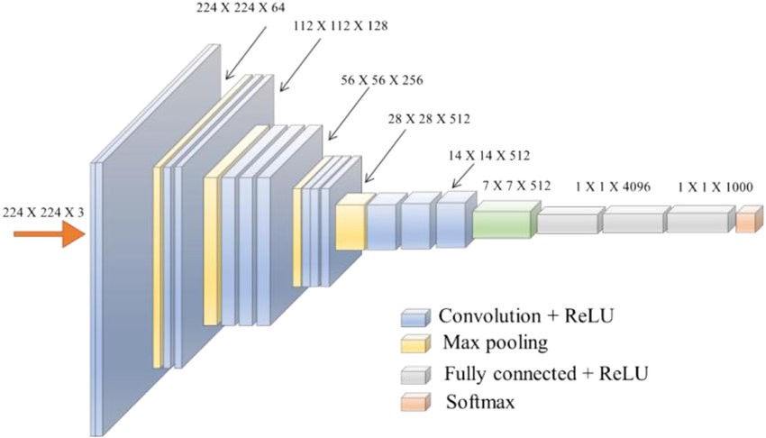

Figure 8.3: VGGNet Architecture [7]

VGG16 differs from AlexNet in that it layers smaller filters on top of each other rather than utilizing a single big filter. Convolutional filters' receptive fields are closely tied to the intuition underlying this. A pixel in a 7 x 7 kernel gets data from 49 pixels in the preceding layer. This is the pixel's receptive field. Higher receptive fields are able to collect more motifs in a larger region while missing out on the details. On the other hand, smaller receptive fields are unable to capture broad patterns. VGG16 contains about 129 million trainable parameters, making it nearly six times the size of AlexNet.

# Naming Conventions and Definitions

## Definitions of Key Terms

All Terms, including acronyms and abbreviations, used in the project is defined at some point. The most important ones are listed here.

Names are very important. They invoke meanings that, if carefully defined, can save hours of explanations. Attention to names at this stage of the project helps to highlight misunderstandings. The glossary produced during requirements is used and extended throughout the project.

SARS:

Severe acute respiratory syndrome is a viral respiratory disease caused by a SARS-associated coronavirus.

ROC:   
Receiver operating characteristic curve is a graph showing the performance of a classification model at all classification thresholds.

AUC:

Area under the ROC curve measures the entire two-dimensional area underneath the entire ROC curve form (0, 0) to (1, 1).

API:

An application programming interface is a computing interface that defines interactions between multiple software intermediaries.

LOC:

Source lines of code (SLOC), also known as lines of code (LOC), is a software metric used to measure the size of a computer program by counting the number of lines in the text of the program's source code.

IDE:

Integrated Development Environment

UI:

User interface

UML:

Unified Modeling Language

# Used Tools

## Programming Languages

**JAVA**:

Java is a computer programming language. It enables programmers to write computer instructions using English-based commands instead of having to write in numeric codes. It’s known as a high-level language because it can be read and written easily by humans. Such as English, Java has a set of rules that determine how the instructions are written. These rules are known as its syntax. Once a program has been written, the high-level instructions are translated into numeric codes that computers can understand and execute. [8]

In the project java is used for implementation of mobile devices. It is implemented in android studio.

**PYTHON:**

Python is an interpreted, object-oriented, high-level programming language with dynamic semantics. Its high-level built in data structures, combined with dynamic typing and dynamic binding, make it very attractive for Rapid Application Development, as well as for use as a scripting or glue language to connect existing components together. Python's simple, easy to learn syntax emphasizes readability and therefore reduces the cost of program maintenance. Python supports modules and packages, which encourages program modularity and code reuse. The Python interpreter and the extensive standard library are available in source or binary form without charge for all major platforms and can be freely distributed. [9]

In the project, python is used to compute the percentage of the risk of Covid-19. It is implemented in PyCharm IDE.

**JAVASCRIPT:**

JavaScript is a very powerful client-side scripting language. JavaScript is used mainly for enhancing the interaction of a user with the webpage. In other words, you can make your webpage livelier and more interactive, with the help of JavaScript. JavaScript is also being used widely in game development and Mobile application development. [10]

In the project JavaScript is used to make the web page interactive and static. It is implemented in VSCode.

**SQL:**

SQL stands for Structured Query Language. A query language is a kind of programming language that's designed to facilitate retrieving specific information from databases, and that's exactly what SQL does. To put it simply, SQL is the language of databases. [11]

In the project SQL is used to utilized to interface with database. It is including data fields in their tables, and it will store pictures and operation ID’s for later use.

## Frameworks

**FastAPI**:

Fast API is a modern, fast (high-performance), web framework for building APIs with Python 3.6+ based on standard Python type hints. The key features are: Fast: Very high performance, on par with NodeJS and Go (thanks to Starlette and Pydantic). One of the fastest Python frameworks available. [12]

In the project, FastAPI is used for the web application. It is suitable for the backend.

**REACT:**

ReactJS is an open-source JavaScript library that is used for building user interfaces specifically for single-page applications. React allows developers to create large web applications that can change data, without reloading the page. The main purpose of React is to be fast, scalable, and simple. [13]

In the project, react is used for handling the view layer for the web. It is also used for creating UI components and changing data without reloading the web page.

**TENSORFLOW:**

TensorFlow is an open-source framework developed by Google researchers to run machine learning, deep learning, and other statistical and predictive analytics workloads. Like similar platforms, it's designed to streamline the process of developing and executing advanced analytics applications for users. [14]

In the project, TensorFlow is used for building models using data flows.

**TENSORFLOW-LITE:**

TensorFlow Lite is a set of tools to help developers run TensorFlow models on mobile, embedded, and IoT devices. It enables on-device machine learning inference with low latency and a small binary size. [15]

In the project, TensorFlow-lite is used for building models using data flows, especially for the android application.

## Other Useful Languages

**HTML:**

HTML stands for Hypertext Markup Language. It allows the user to create and structure sections, paragraphs, headings, links, and blockquotes for web pages and applications. HTML is not a programming language, meaning it doesn’t have the ability to create dynamic functionality. Instead, it makes it possible to organize and format documents. [16]

In the project, html is used to create general web page structure, paragraphs, headings, links and so on.

**CSS:**

CSS stands for Cascading Style Sheets. It is a style sheet language which is used to describe the look and formatting of a document written in markup language. It provides an additional feature to HTML. It is generally used with HTML to change the style of web pages and user interfaces. [17]

In the project, CSS is used for including colors, layouts and fonts. It also allows one to adapt the presentation to different types of devices, such as large screens, small screens.

## Platforms

**PYCHARM:**

PyCharm is a Python IDE with a complete set of tools for Python development. In addition, the IDE provides capabilities for professional Web development using the FastAPI framework. Code faster and with more easily in a smart and configurable editor with code completion, snippets, code folding and split windows support. [18]

PyCharm is used to implement the project's machine learning part. In this part of the application:

* Data preparation
  + Gather data. The data preparation process begins with finding the right data.
  + Discover and assess data. After collecting the data, it is important to discover each dataset.
  + Cleanse and validate data.
  + Transform and enrich data.
  + Store data.
* Analyze Data
* Model architecture
  + Convolution
  + ReLU Activation Function
  + Pooling
  + Flattening
  + Full Connection
* Model evaluation
  + Accuracy
  + Precision
  + Recall
  + F1
  + Sensitivity
  + Specificity
  + ROC
  + AOC
* Visualization
  + Visualization of model evaluation metrics.
  + Other visualization techniques.

**VSCODE:**

Visual Studio Code is a streamlined code editor with support for development operations like debugging, task running, and version control. It aims to provide just the tools a developer needs for a quick code-build-debug cycle and leaves more complex workflows to fuller featured IDEs. [19]

VSCode is used to implement the project's web application. In the application: there are some tags and functional attributes:

* Several labels to show user what to enter.
* Several inputs to enter necessary register information.
* Another button to confirm and complete register.
* Alert if invalid entry.
* Several inputs to enter login information.
* Another button to confirm and complete login.
* Alert if invalid entry.
* A button that chooses a picture which is an X-ray.
* An input to enter code.
* Label to show the results.
* Another button to logout.

**ANDROID STUDIO:**

Android Studio provides a unified environment where you can build apps for Android phones, tablets, Android Wear, Android TV, and Android Auto. Structured code modules allow you to divide your project into units of functionality that you can independently build, test, and debug. [21]

Android Studio is used to implement the project's android application. In the application: there are some tags and functional attributes:

* Several text view to show to user what to enter.
* Several plain text to enter necessary register information.
* Another button to confirm and complete register.
* Pop-up if invalid entry.
* Several plain text to enter login information.
* Another button to confirm and complete login.
* Alert if invalid entry.
* A button that chooses a picture which is an X-ray.
* A plain text to enter code.
* Textbox to show the results.
* Another button to logout.

**FIREBASE:**

Firebase is a Backend-as-a-Service. It provides developers with a variety of tools and services to help them develop quality apps, grow their user base, and earn profit. It is built on Google's infrastructure. Firebase is categorized as a NoSQL database program, which stores data in JSON-like documents. [21]

In the project, firebase is used as database for android. It allows to handle data in real-time, which means that when the data is generated or edited, other users may see the changes in the data.

**POSTGRESQL:**

PostgreSQL (often referred to as Postgres) is an open-source object-relational database management system with a particular focus on extensibility and standards compliance. [22] It uses and extends the SQL language combined with many features that safely store and scale the most complicated data workloads.

In the project, PostgreSQL is used as database for web. It utilized to interface with databases. It is including data fields in their tables, and it will store pictures and operation ID’s for later use.

# Relevant Facts and Assumptions

## Facts

* Implementation will be written on platforms such as PyCharm for neural network and modelling, VSCode for web development, android studio for android development.
* Implementation will be written in several programming languages such as Python, Java, JavaScript.
* When a user clicks the upload button, she/he can choose x-ray as an image and that image must be successfully uploaded to the system.
* When a user clicks the application. The application must open without any error.
* The system must print whether the person has the virus or not.
* The existing application is 2000 LOC.

## Assumptions

* Identify at least %95 of the covid-19 correctly
* This project will help the situation of pandemic.
* The application will get around five hundred requests a day.

II Requirements

# Software Requirements Specification

A System Requirements Specification (SRS) is a documentation set that describes a system or software application's features and behavior. It involves a variety of elements that attempt to define the customer's intended functionality to satisfy their various users. This part of the project report elicits the information about the aim of the software program. The functionalities that will be encapsulated and the descriptions how they will be done also are revealed in this section.

The SRS is simply a text explaining what it is intended to do with the program, but not how it would do it. It can be plain text, but using diagrams also makes sense. Using structured UML diagrams like Use Case or Operation is also a good idea. Some diagrams of the project as in the below:

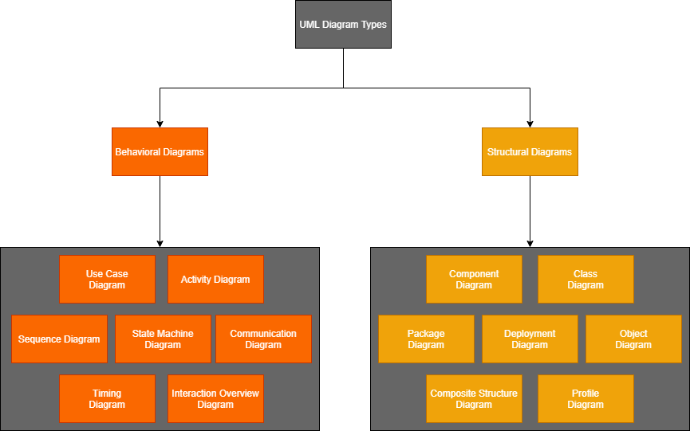

Figure 12.1.: UML Diagram Types

# Behavioral Diagrams

## Use Case Diagrams

Describes a series of activities that can be performed by some software system or systems in cooperation with one or more external software system users (actors) in order to provide some tangible and valuable results to the system's actors or other stakeholders.

### Registration Use Case

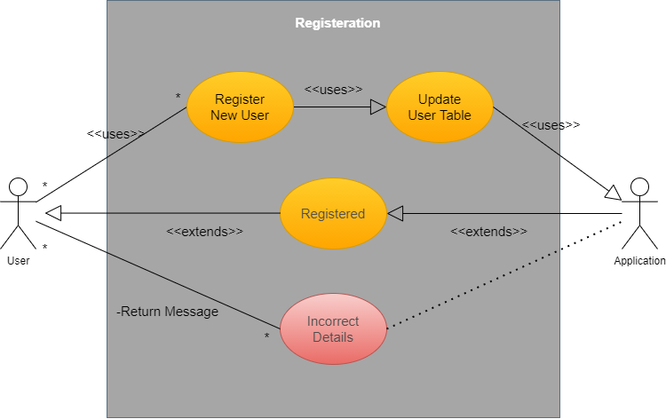

Figure 13.1.: Registration Use Case

### Login Use Case

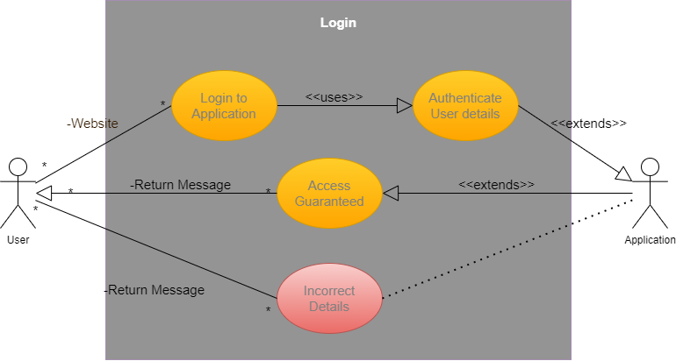

Figure 13.2.: Login Use Case

### Upload an Image Use Case

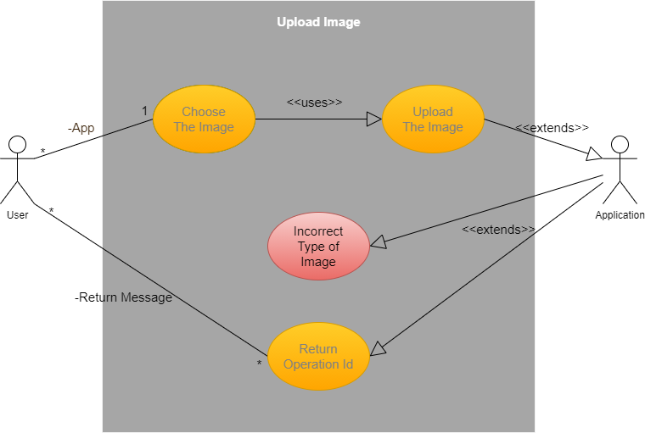

Figure 13.3.: Upload an Image Use Case

### Enter the Operation Id Use Case

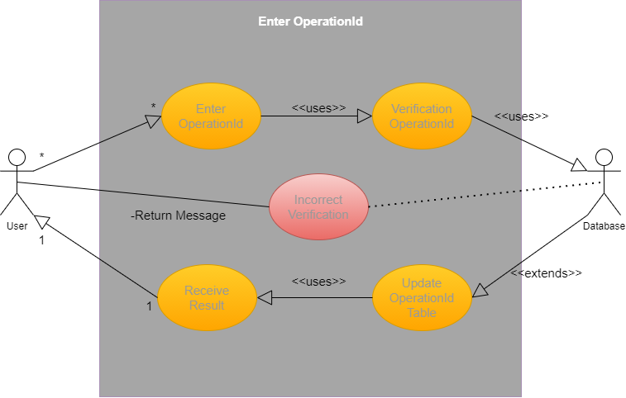

Figure 13.4.: Enter the Operation Id Use Case

## Activity Diagram

Shows the sequence and conditions for low-level behaviors, rather than the classifiers that own certain behaviors.

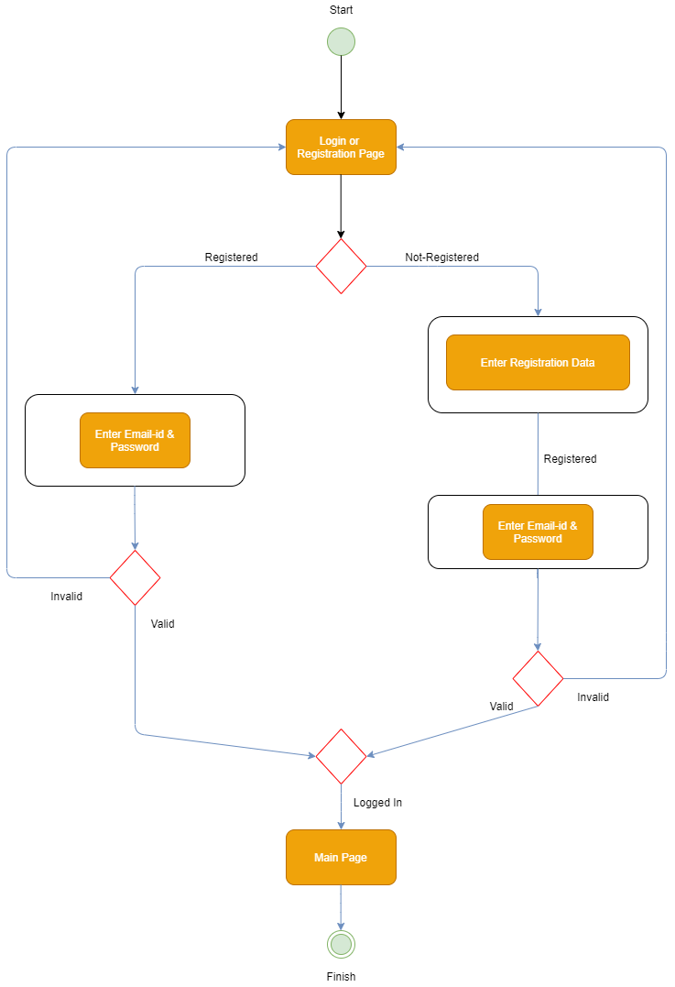

Figure 13.5.: Register Login Activity Diagram

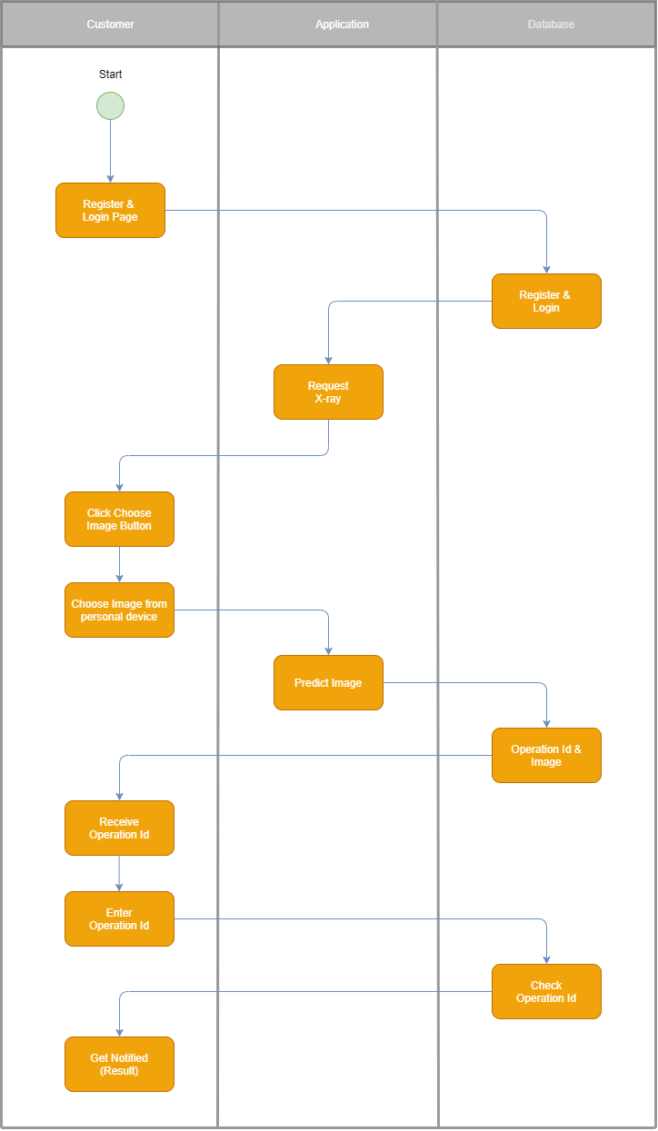

Figure 13.6.: Operation Activity Diagram

## Sequence Diagram

The most popular type of interaction diagram that shows the exchange of messages between items.

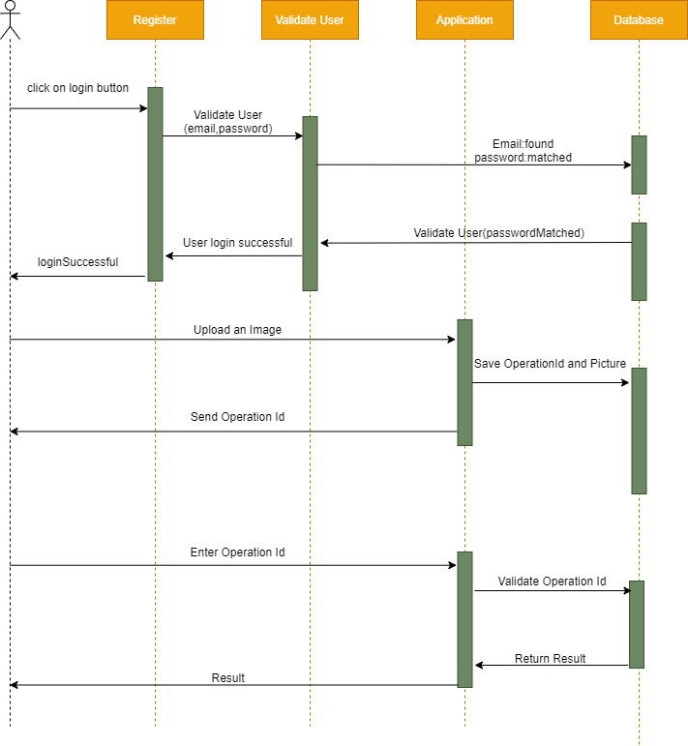

Figure 13.7.: Sequence Diagram

## Communication Diagram

It focuses on the interaction between objects in which the internal structure architecture is fundamental and how this relates to the passing of the message. The message sequencing is given via a scheme of sequence numbering.

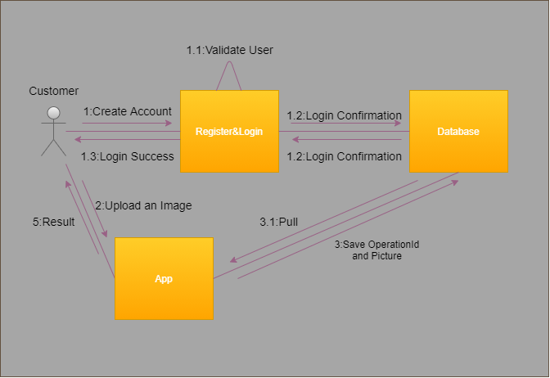

Figure 13.8.: Communication Diagram

## Interaction Overview Diagram

Define interactions via a variant in such a way that the control flow overview is assisted. These diagrams concentrate on the description of the control flow of interactions between the nodes. At this overview step, the objects and the messages do not show up.

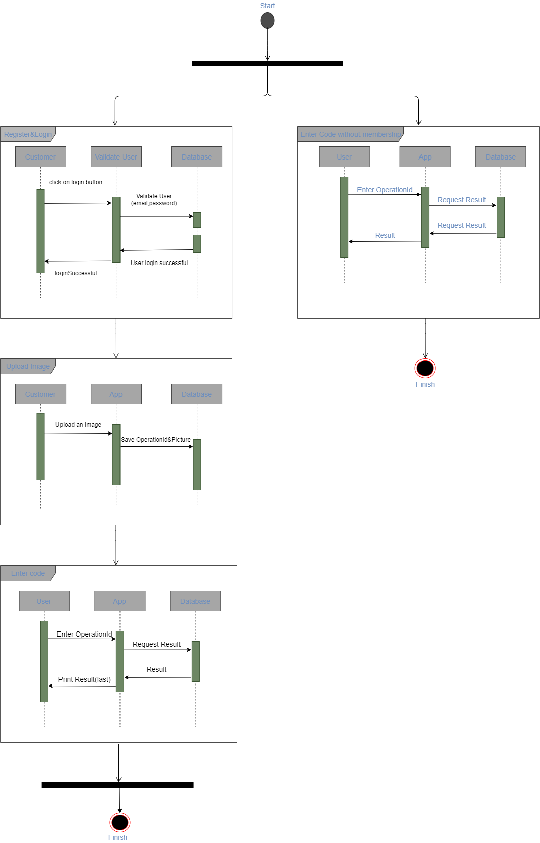

Figure 13.9.: Interaction Overview Diagram

# Functional Requirements

Functional requirements are the requirements that ought to consist of crystal-clear direction of how to perform a particular task. They should specify the anticipated behavioral of the software system. Concisely, functional requirements describe which output must be produced for a specific given input.

## Details of a Customer

**Input:** Customer provides correct credentials.

**Process:** The customer enters the correct credentials. The provided credentials are sent to system to verify and they get verified.

**Output:** Customer gets login into system. Hereupon, the customer is able to inspect and use the system.

## Details of a Customer’s Operation

**Input:** Customer will enter the operation id.

**Process:** Thediagnosis based on the chest x-ray, which was uploaded by the customer, and all the details about the operation can be accessible by entering the relevant operation’s id.

**Output:** Display a screen of diagnosis and relevant details about the operation.

## Diagnose

**Input:** The customer uploads a proper chest x-ray.

**Process:** The software system should examine the chest x-ray based on the artificial intelligence model that has been using and produces an output in two hours.

**Output:** Diagnostic of the person whose chest x-ray belongs is Covid-19 or not.

## Accepting Payment to Accelerate the Process

**Input:** The customer pays after uploading the chest x-ray

**Process:** When chest x-ray photo is uploaded, software system starts trying to diagnose right away but it takes two hours per photo unless customer pays for a predetermined price.

**Output:** Diagnostic of the person whose chest x-ray belongs is Covid-19 or not

under 5 minutes.

# Data Requirements

Directives or consensus agreements that specify the material and/or structure that constitute high-quality data cases and values are prescribed data specifications. Several distinct individuals or groups of individuals will therefore state the data criteria. In addition, the data requirements can also be focused on rules, standards, or other directives. They can be agreed upon or contradicted by one another.

In terms of defining the basic flow of entities thru the system, a flow diagram is useful. It helps for documenting and visualizing the physical flow of entities. Just as a flow diagram is created, those familiar with the operation should manage a structured walk-through to ensure that the flow is right and that nothing has been missed. The next step would be to describe the detail of how organizations travel between locations and what resources are used for conducting operations at each location. It is necessary to define position capabilities, movement times, processing times, etc. at this stage.

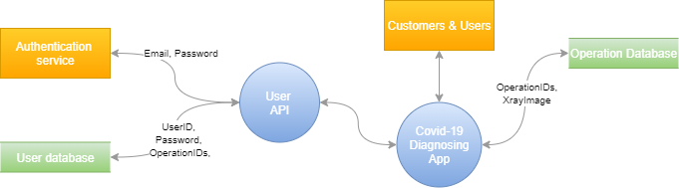

Figure 15.1.: Data Flow Diagram

As can be inspected in the data flow diagram, there are a few data requirements in the project. These data requirements are crucial for software program to work flawlessly. Even if one of the data requirements is not provided, then the software program won’t be able fulfil its duty accomplishedly. Data requirements are listed below:

* Email: Email address of customer
* Password: Password of customer
* XrayImage: Chest x-ray of customer
* OperationID: ID of the relevant operation, assigned by the system.

# Performance Requirements

Performance determines how quickly a software system, or its specific component reacts to the actions of certain users under certain workload. In most instances, this metric explains how long a user must wait before the target procedure occurs (the page renders, a transaction is processed, etc.) considering the total number of users at the moment.

## Speed and Latency Requirements

* The prediction of Covid-19 diagnosis must take time under 1 second right after the user uploads a chest x-ray.
* The reaction must be rapid enough to avoid disrupting the user's flow of thought.
* The maximum response time of any interface between the user and the automated system must be under 2 seconds.
* The payment transaction must take time under 10 seconds after the user enters her/his credit card information whether the payment is successful or not.
* The Android application of the product must not take more than 3 seconds while its opening.

## Precision or Accuracy Requirements

* All accuracy of the prediction’s data must be accurate to two decimal points.
* The prediction of the Covid-19 diagnosis, that is based on the chest x-ray of user’s, must have at least %95 accuracy whether the diagnosis is positive or not.

## Capacity Requirements

* 1000 simultaneous users shall be served by the product during the time from 9:00 a.m. to 6:00 p.m. For other times, the maximum load would be 350 simultaneous users.
* The software system shall be able to manage up to 30,000 customer records with 3 images per customer. In other words, the software system shall be able to store 90,000 chest x-ray images, that have 224 height and 224 width pixels, in total.

# Dependability Requirements

## Reliability Requirements

For most software products, reliability is an essential non-functional requirement, so a software requirement specification (SRS) should, and most do, include a reliability requirement. However, one of the quality measures of a 'good' requirement is that it is testable, so it is fair to question if the specifications for reliability in an SRS are testable as written.

The reliability requirements of the product are listed in the following:

* The software system must not fail more than thrice a week.
* There must not even a piece of data of any user's lost or get damaged during

the event of a failure.

* Even tough software system fails, it must not crash in UI (User Interface).

## Availability Requirements

Availability means that the directory service has an agreed minimum uptime and output standard. Failure, in this context, is defined as something that prevents this minimum service level from being provided by the directory service.

The availability requirements of the product are listed in the following:

* The software must available 24 hours per day, 7 days per week and 365 days per year.
* The product must achieve %99.5 uptime which equates to 7.20 minutes downtime per day.
* Less than 20 seconds is required to restart the system after a failure %95 of the time which is an MTTR (Mean-Time to Repair) requirement.

# Security Requirements

Security requirement is a declaration of the security features necessary that guarantees that all of the software's many different security properties is fulfilled. Safety specifications are derived from industry requirements, laws in place, and a database of past vulnerabilities.

## Access Requirements

Specification of who has allowed access (both functionality and data) to the software, under what circumstances the access is granted and in which sections of the access to the product is permitted.

The availability requirements of the product are listed in the following:

* Only customer see his/her operation history.
* Anyone, who has an operation id, can see the details about the operation.

## Data Integrity Requirements

The integrity of data is the security property that guarantees that information meets a given quality expectation and has not been exposed to accidental or malicious alteration or destruction. All input data must be checked sufficiently. Information services must comply with standards for data integrity.

The data integrity requirements of the product are listed in the following:

* The software system must protect itself from intentional abuse.
* The software system must prevent incorrect data from being introduced.

## Privacy Requirements

Privacy specifications are statements that relate to key privacy priorities and define features and functions that must be able to be performed by a device.

The privacy requirements of the product are listed in the following:

* The software notifies customers of alternations to its information policy.
* The software system makes the users aware of its information practices before its collecting data from the users.
* The software system protects private information in accordance with the related privacy laws and the organization’s information policy.

# Quality Requirements

Specifications of the quality of goods, facilities, processes or environments are quality specifications. Quality is any aspect that gives things meaning beyond their functionality and characteristics, tangible or intangible.

## Efficiency Requirements

Efficiency requirements describe the extent to which resources are optimally used by the software, the speed at which the system is executed, and the memory it consumes for its operation.

The efficiency requirements of the product are listed in the following:

* The software system must be able to operate at least two times faster than existing system.
* The software system must be able to decrease %10 memory usage than the existing system.

## Portability Requirements

The ease with which software can be moved from one platform to another is defined by portability requirements.

The portability requirements of the product are listed in the following:

* It must be easy to transport the software to a different operating system from the current one without the need of redesigning the entire software system.

III Design

# System Design

System designs comprise of processing the designing of the elements of a system, for instance architectures, components and modules.

## Design Goals

Design priorities must be established in the process of moving from the analysis model to constructing the system design. These will define the attributes that must be concentrated on by the system so that design decisions can be made on a particular set of parameters.

Most of the design goals can be comprehended by inspecting non-functional requirements that was mentioned in the report [26.-29.]. In despite of the non-functional requirements, there are a few things that must be extended.

Initially, one of the most important part is customer sign up and sign in parts. A customer must be able to sign up and sign in quickly because of the project is in healthcare field. Moreover, after the customer enters the system, s/he should be able to upload a chest x-ray of her/him right away without a confusion of where to click. UI/UX design is as much important as system architecture.

Secondly, software system should be designed in such a way that when the customer uploads a chest x-ray image, software system must work in the background smoothly and even if there is an error occurred, it should not crash and inform the customer about it. In the light of these, because of the software system not crashing, the availability of the app will hit at least %99 of the time.

Every piece of detail, that we asked the permission to keep, must be kept into the database that the software system has been using. The alleged chest x-ray image is uploaded to the software system and throughout the operation system there must not be any interaction between software system and database for preventing the database from unnecessary burden. If the operation system has done, then the software system can keep the relevant data into the database. The database must be normalized, and any data of any user should not be lost during any downtime.

# System Architecture

"Architecture is about the important stuff. Whatever that is.” — Ralph Johnson

Systems Architecture is a general discipline called "systems" to work with structures (existing or to be created), in a manner that encourages thinking about the structural properties of these objects. Systems Architecture is a solution to the intellectual and functional challenges of complex systems explanation and construction.

## Overview

The software system provides a robust, secure, and highly performant diagnosis system over both web browser and android. The diagnosis system is specialized for Covid-19 disease only at the moment but the time this project report has been reading, there may be more than one disease can be detected and diagnosed by using the software system. A diagnosis system is a powerful yet simple software system that makes working easier for many people who works in the field of healthcare.

Out of the box deep learning, the software system is easy to comprehend how to use and at the same time, it is a great lead on the way of inspiring people both who are new to the field and who are working in the field for a long time by using the simple yet efficient architecture of the deep learning model. The idea of deploying deep learning model helps to make it as small as it is efficient. Deep learning models are too big to store and as it is known, the model needs to be run every time a diagnosis would perform. So, the system architecture was designed to provide the best situation, taking all these situations into consideration.

## Dynamic Models

### Class Diagram

Shows the overall conceptual modeling structure, such as subsystem, component, or engineered device. There are groups and interfaces synonymous with their attributes, generalizations, shortcomings, interactions, partnerships, dependencies.

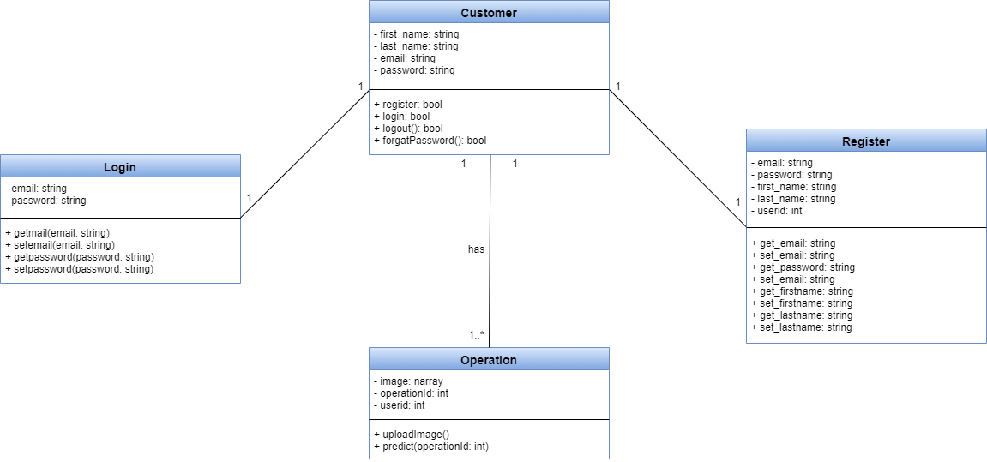

Figure 11.5.: Class Diagram

### Component Diagram

It indicates components, interfaces, and correlations between them that are fulfilled and required.

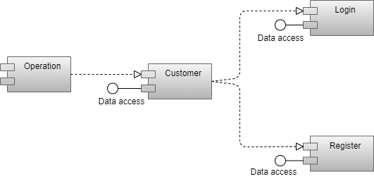

Figure 11.5.: Component Diagram

### Deployment Diagram

Deployment diagram is the structure of the delivery of software objects to deployment items.

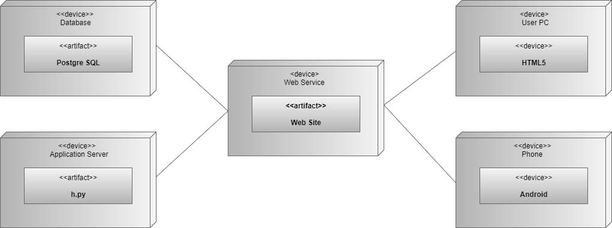

Figure 11.5.: Deployment Diagram

### Object Diagram

Instance level class diagram that displays class and interface instance requirements, value specification slots, and association examples (links).

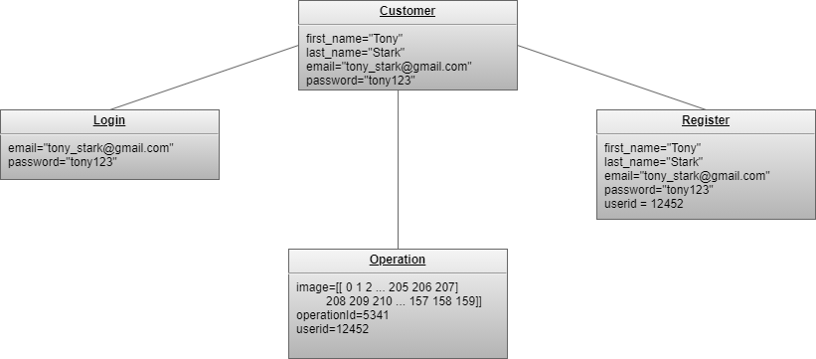

Figure 11.5.: Object Diagram

# Outputs

## Web Application

### Back-end Endpoints

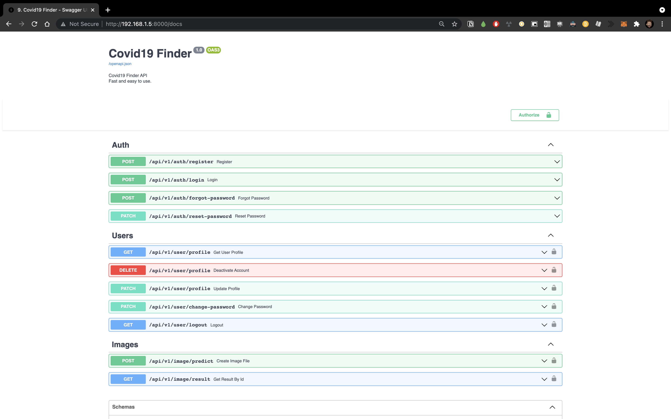

Figure 21.1: Back-end endpoints

### Front-end Main Page

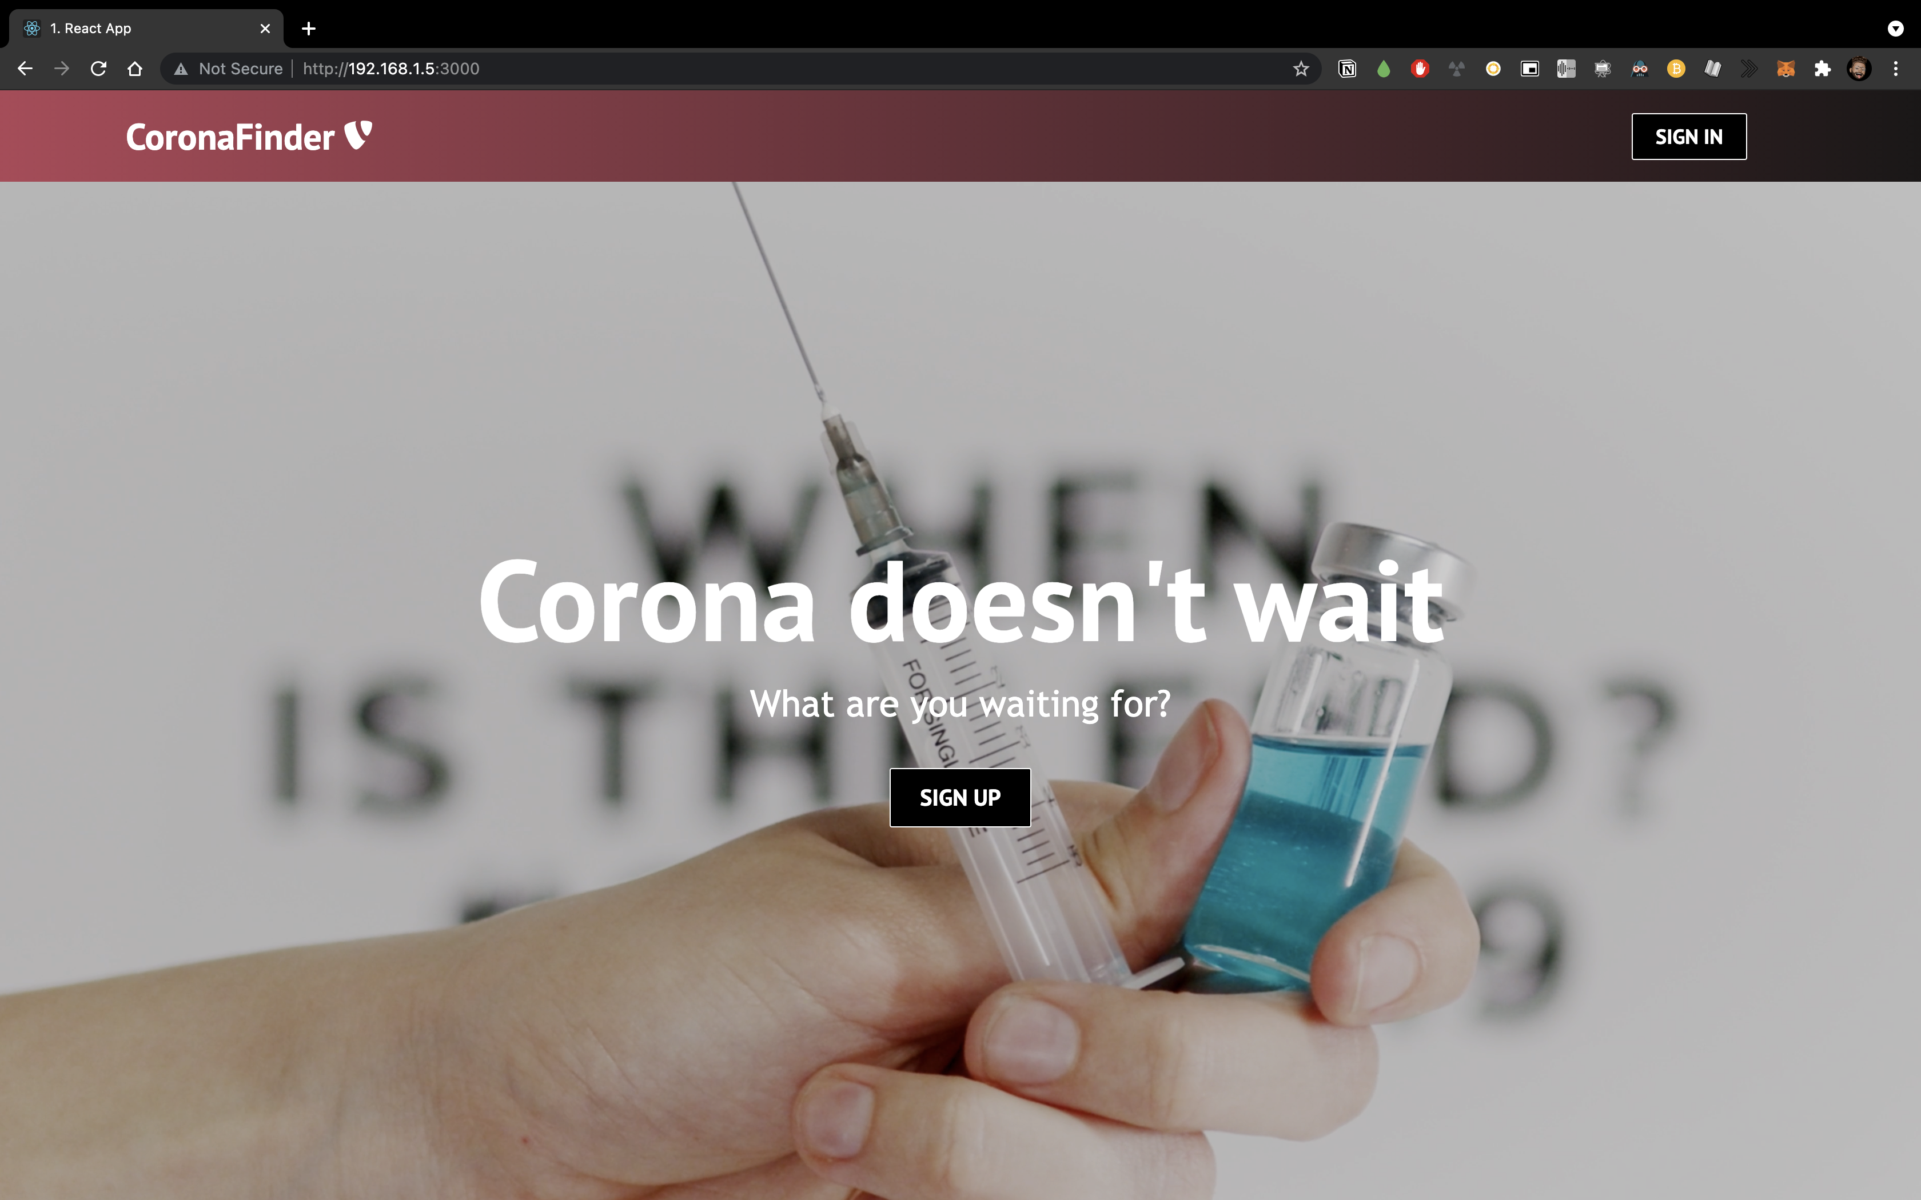

Figure 21.2: Front-end Main Page

### Front-end Sign-In Page

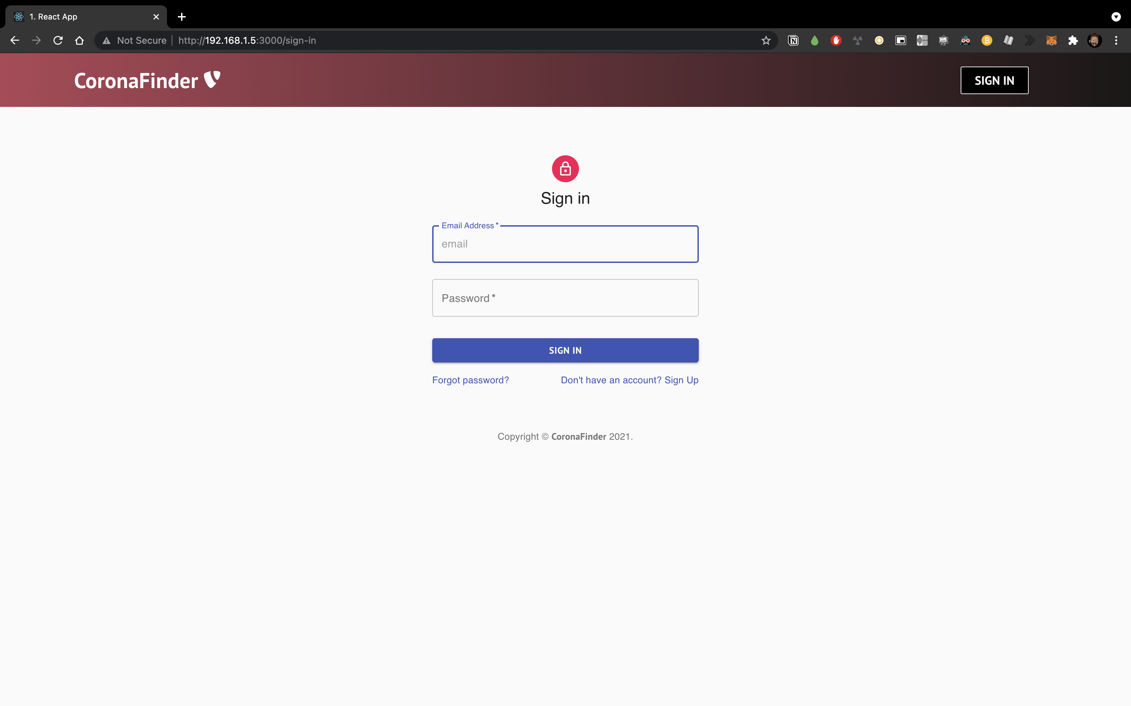

Figure 21.3: Front-end Sign-In Page

### Front-end Sign-Up Page

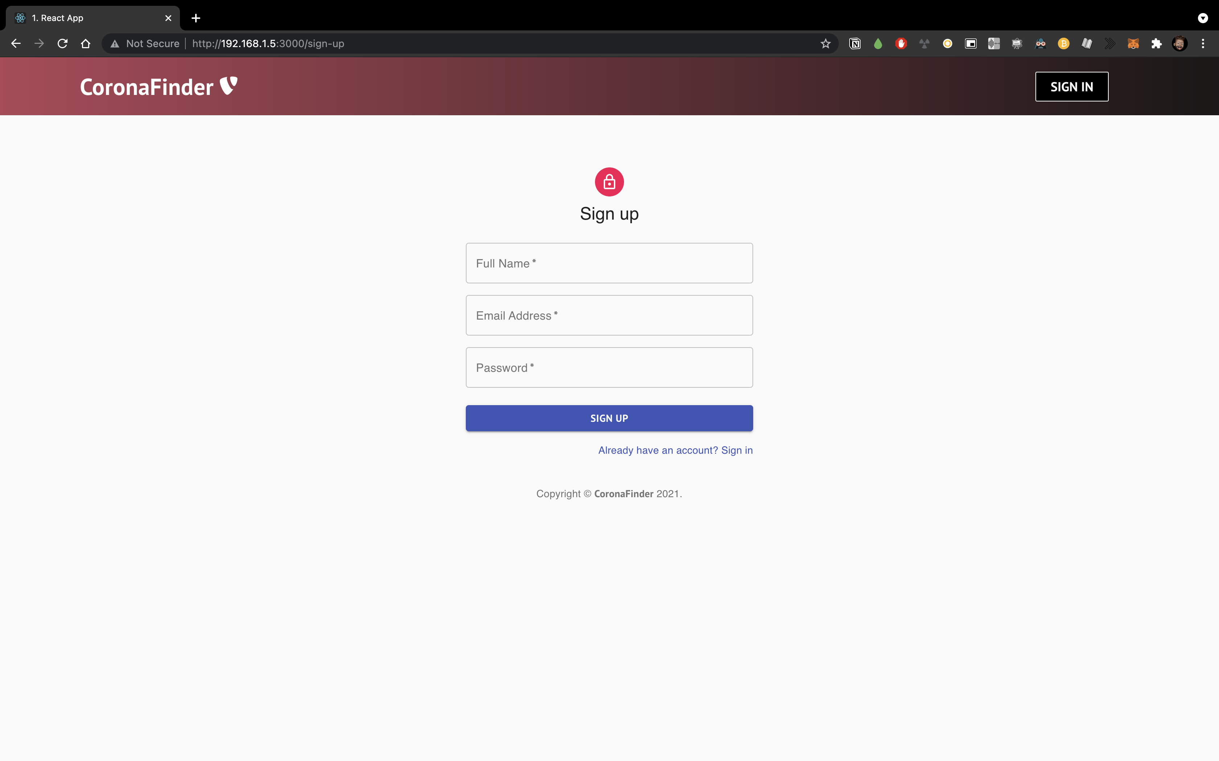

Figure 21.4: Front-end Sign-Up Page

### Front-end Forgot Password Page

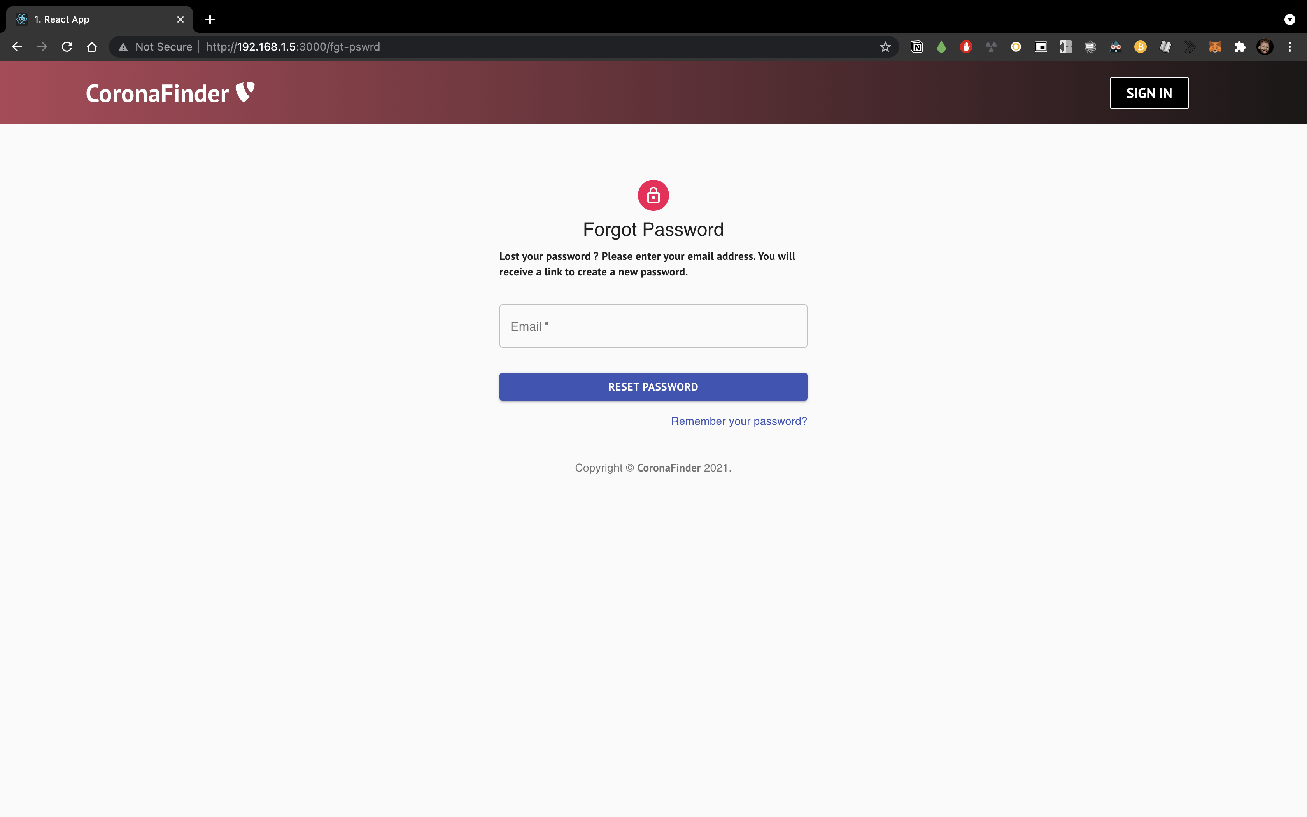

Figure 21.5: Front-end Forgot Password Page

## Mobile Application

### Mobile Application Main Page

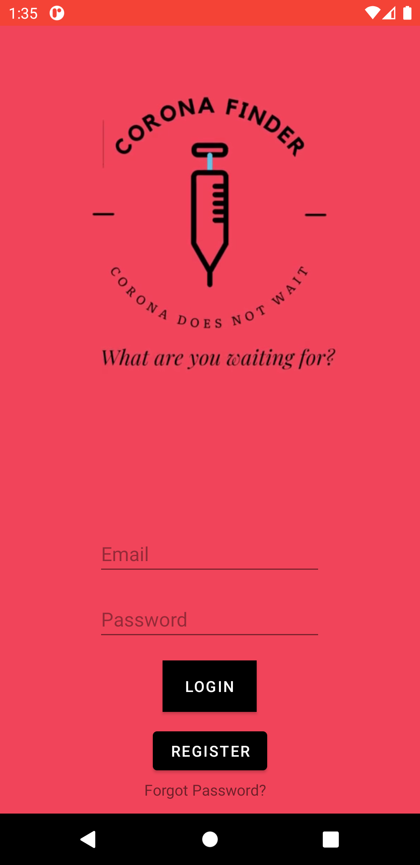

Figure 22.1: Mobile Application Main Page

### Mobile Application Register Functionality

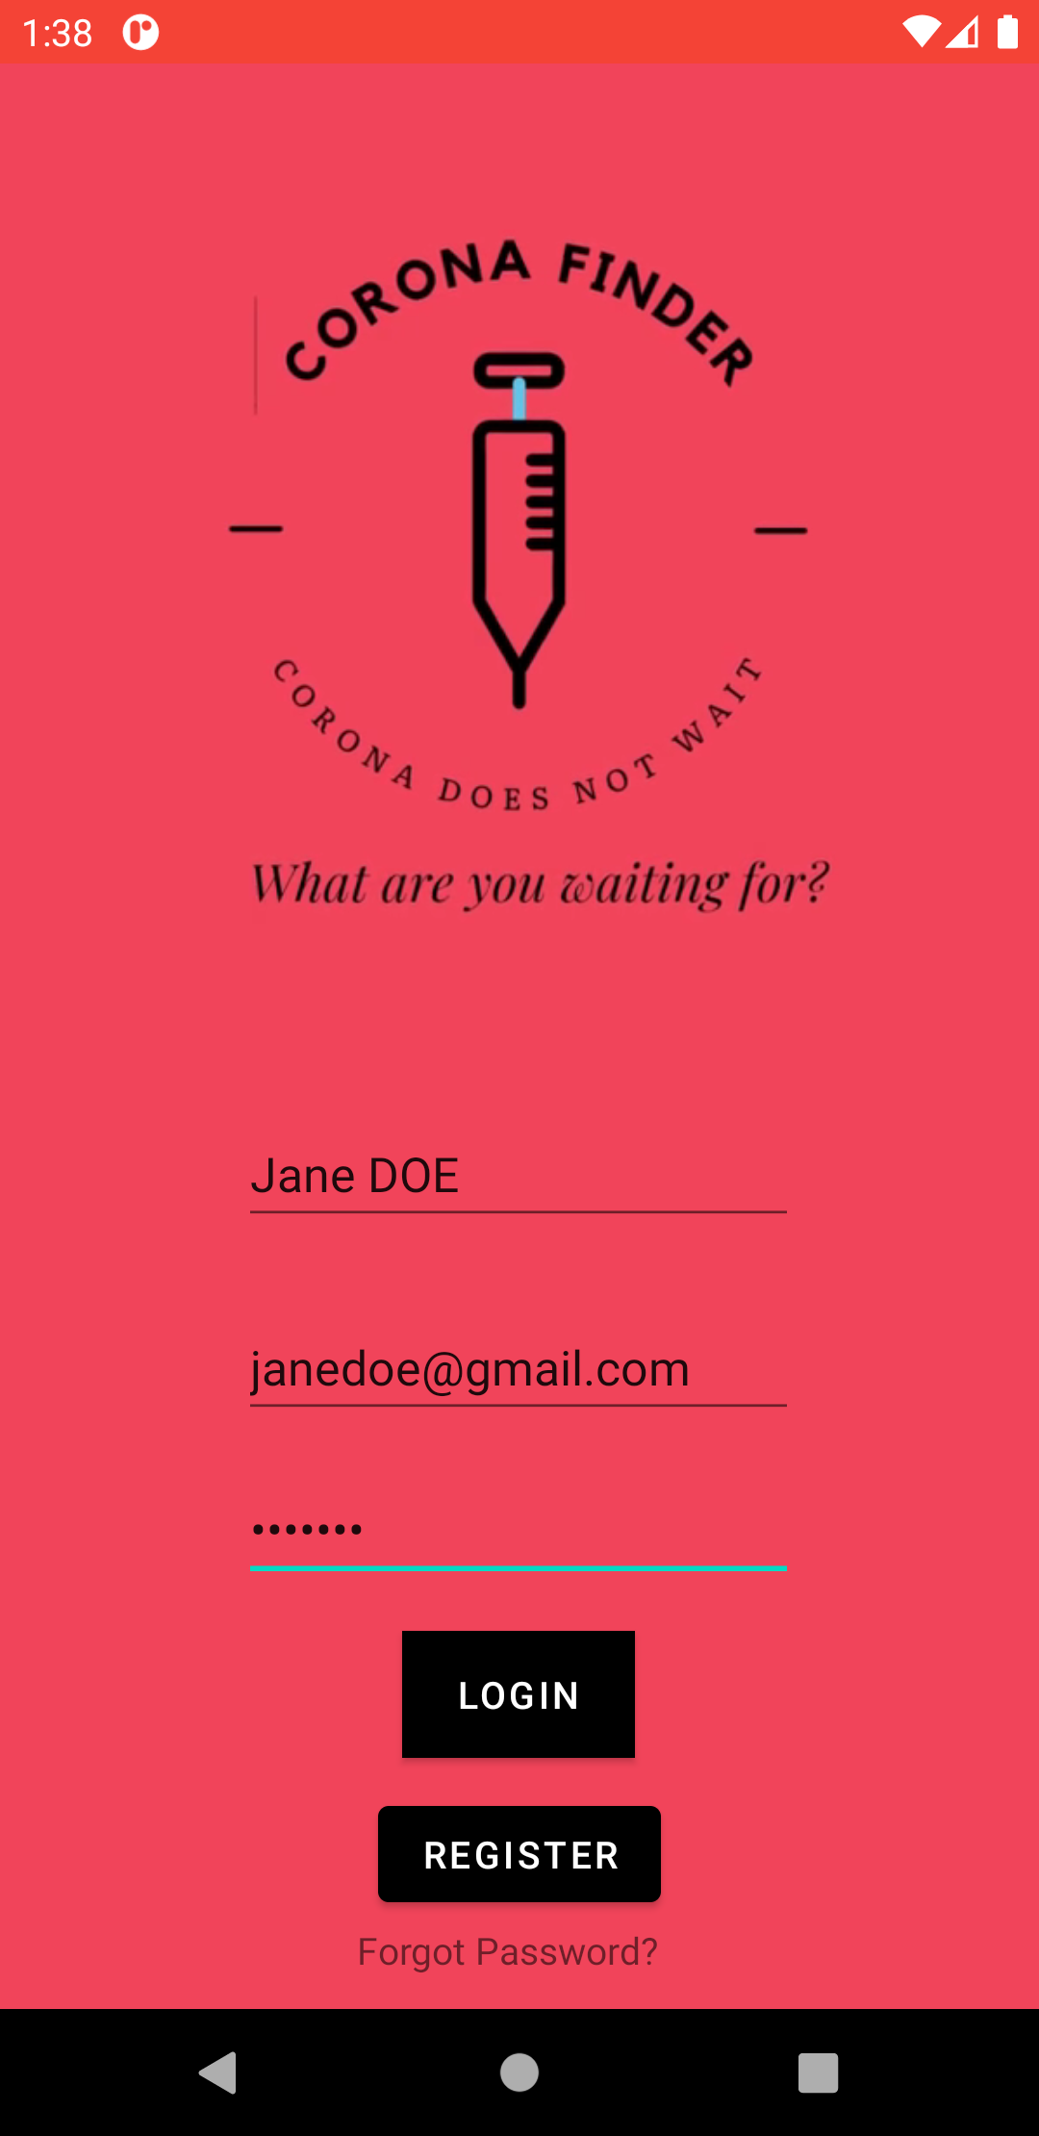

Figure 22.2: Mobile Application Register Functionality

### Mobile Application Select Image



Figure 22.3: Mobile Application Select Image Page

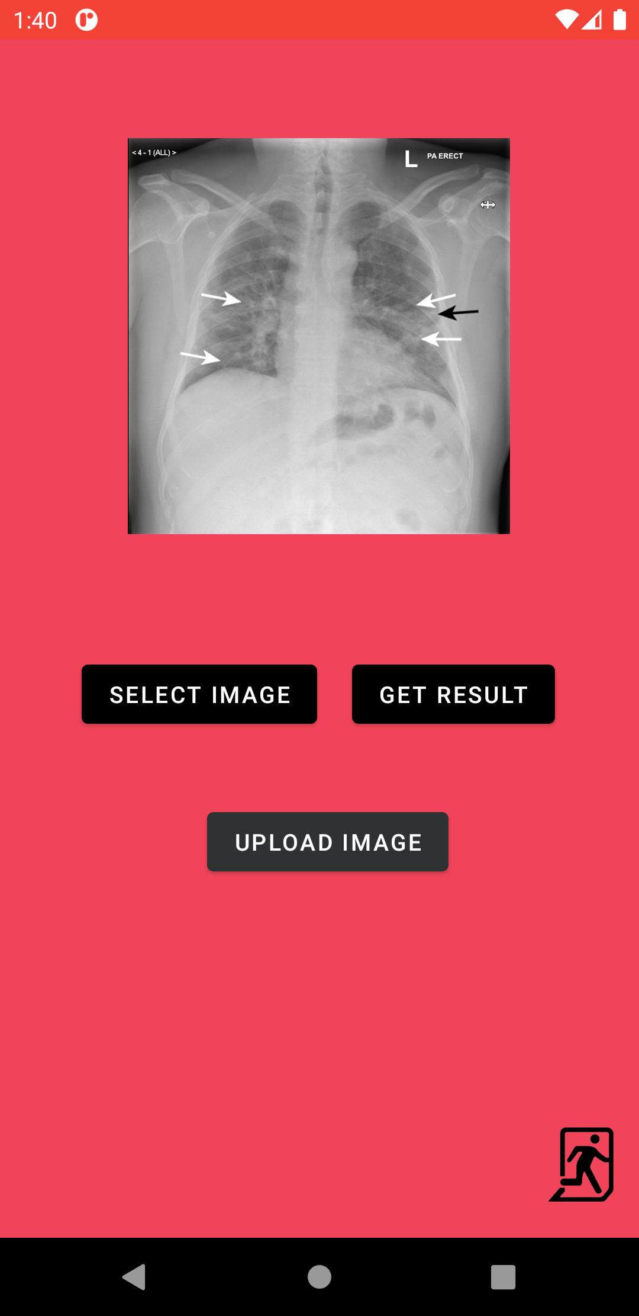

Figure 22.4: Mobile Application Image Upload View

### Mobile Application Image Upload

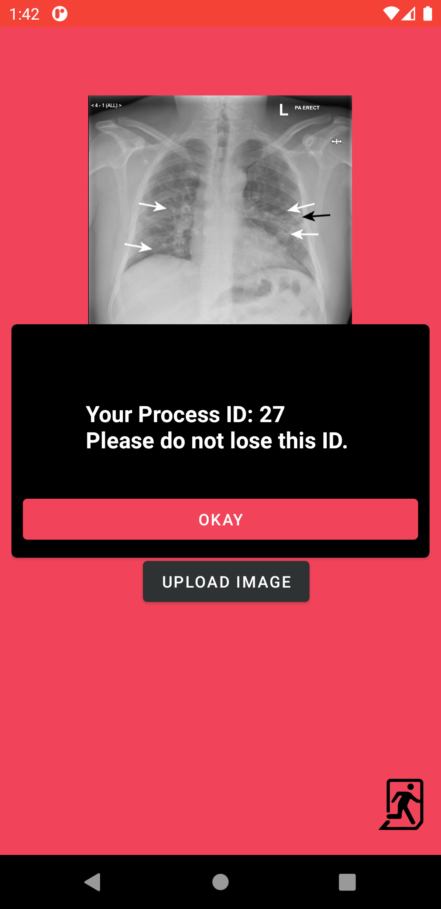

Figure 22.5: Mobile Application Image Upload Provides Process ID

### Mobile Application Get Result

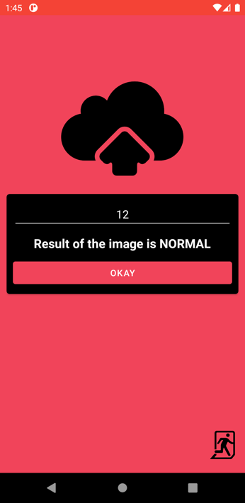 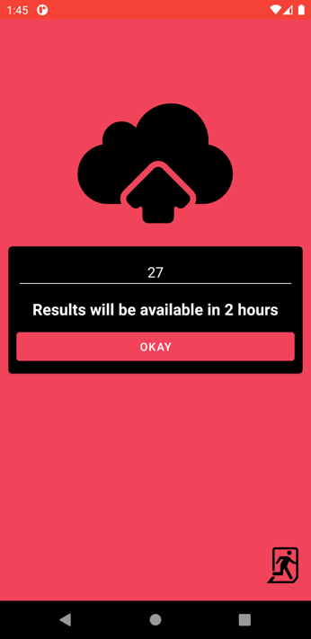

Figure 22.6: Mobile Application Get Result Outputs

**References:**

[1] Differences Between X-Rays, CT scans & MRI's

<https://www.envrad.com/difference-between-x-ray-ct-scan-and-mri/>

[2] Classification of COVID-19 patients from chest CT images using multi-objective differential evolution–based convolutional neural networks

<https://www.ncbi.nlm.nih.gov/pmc/articles/PMC7183816/>

[3] Convolutional Networks for Images, Speech, and Time-Series

<https://www.researchgate.net/publication/2453996_Convolutional_Networks_for_Images_Speech_and_Time-Series>

[4] Outputs of Intermediate Layers for Detecting Plant Disease

<https://www.researchgate.net/publication/333048923_How_Convolutional_Neural_Networks_Diagnose_Plant_Disease/figures?lo=1>

[5] Convolution Process Leads to Feature Maps

<https://mlnotebook.github.io/post/CNN1/>

[6] Simonyan, Karen & Zisserman, Andrew. (2014). “Very Deep Convolutional Networks for Large-Scale Image Recognition”. arXiv 1409.1556.

[7] Pandiyan, Vigneashwara & Tjahjowidodo, Tegoeh & Caesarendra, Wahyu & Murugan, Pushparaja. (2019). “In-process virtual verification of weld seam removal in robotic abrasive belt grinding process using deep learning”. Robotics and Computer-Integrated Manufacturing. 57. 477–487. 10.1016/j.rcim.2019.01.006.

[8] What is Java?

<https://www.thoughtco.com/what-is-java-2034117>

[9] What is Python?

<https://www.python.org/doc/essays/blurb/>

[10] What is JavaScript?

<https://www.dataquest.io/blog/sql-basics/>

[11] What is SQL?

<https://www.guru99.com/introduction-to-javascript.html>

[12] What is FASTAPI?

<https://fastapi.tiangolo.com/>

[13] What is ReactJS?

<https://www.c-sharpcorner.com/article/what-and-why-reactjs/>

[14] TensorFlow

<https://www.tensorflow.org/guide>

[15] TensorFlow-Lite

<https://www.tensorflow.org/lite/guide>

[16] What is HTML?

[https:/www.hostinger.com/tutorials/what-is-html](https://www.hostinger.com/tutorials/what-is-html)

[17] What is CSS?

<https://www.javatpoint.com/what-is-css>

[18] What is IDE and why PyCharm?

<https://www.componentsource.com/product/pycharm/about>

[19] What is editor and why VSCode?

<https://code.visualstudio.com/docs/supporting/faq>

[21] What is Android Studio and why?

<https://developer.android.com/studio/features>

[21] What is Firebase?

<https://www.educative.io/edpresso/what-is-firebase>

[22] What is PostgreSQL?

<https://www.postgresql.fastware.com/what-is-postgresql>